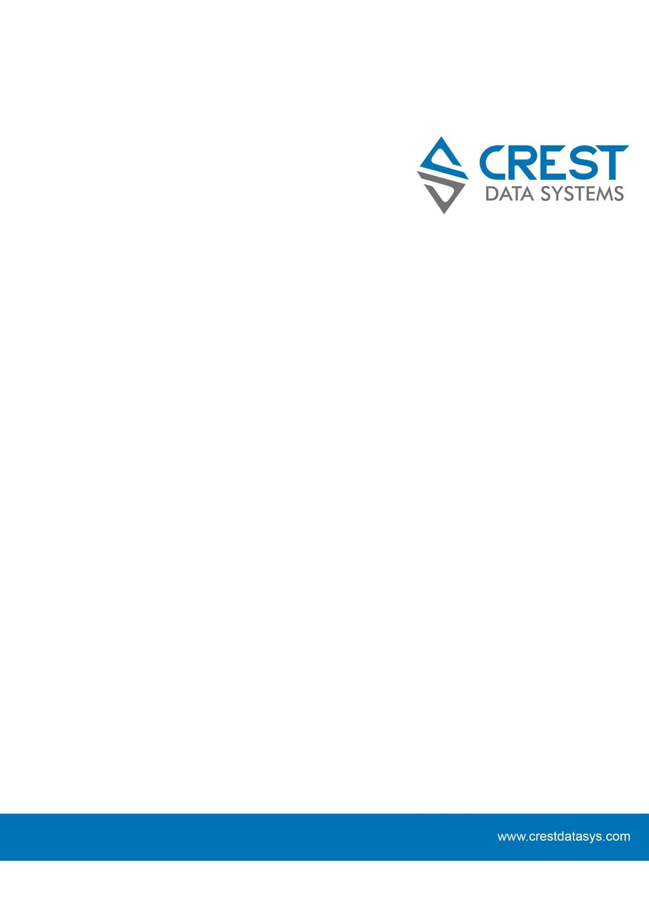

# 

# 

# Version Control

| # | Document Version | Date | Owner | Document Status | Comments |
| --- | --- | --- | --- | --- | --- |
| 1 | 1.0.0 | 08th April 2025 | Crest Data Systems | Initial Solution |  |

# 

# Contents

**Version Control 1**

**Contents 2**

**Steps to Install the Corelight MS Sentinel Integration 3**

**Steps to Configure the Corelight Workbook (Dashboards) 7**

**Steps to Install the Corelight Parser 11**

**Steps to update Watchlist 12**

**Limitations 16**

# 

# Steps to Install the Corelight MS Sentinel Integration

1. Login to the azure portal(<https://portal.azure.com/#home> ), search for Microsoft Sentinel in the search bar and select Microsoft Sentinel service.

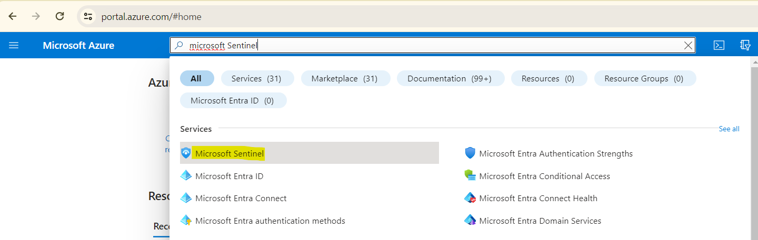

1. Now select your workspace and then go to **Content Hub** and search for Corelight. After finding the solution **click on it** and **click on view details** .

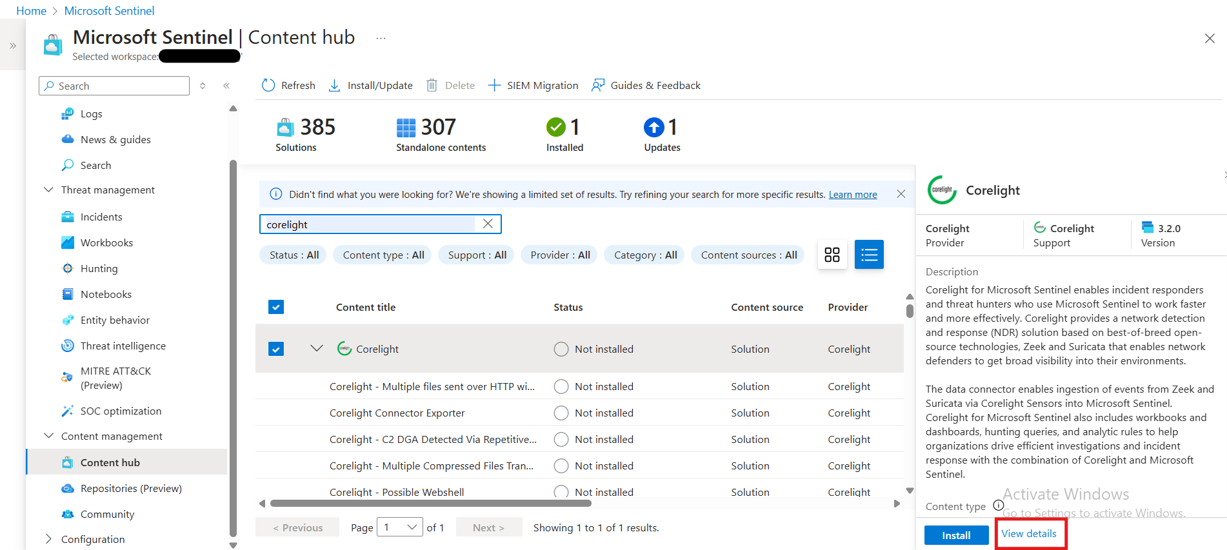

1. After clicking on View Details you will see the screen like the image below. Click on the Create button.

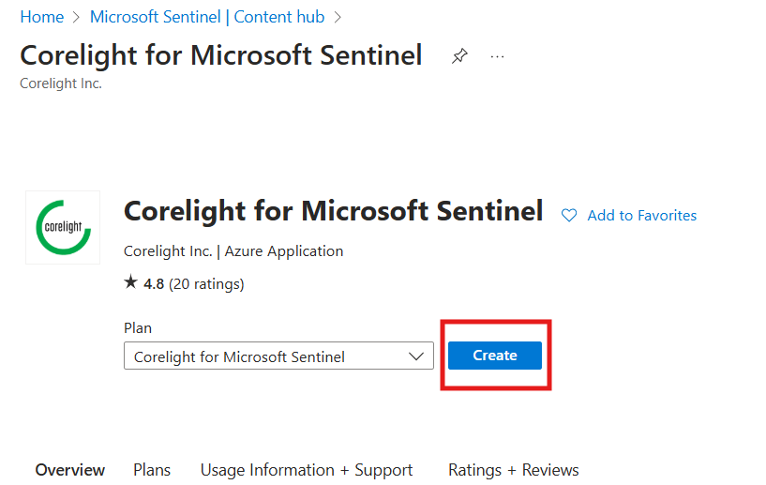

1. Fill in the details of the workspace and resource group then click on **Review + Create.**

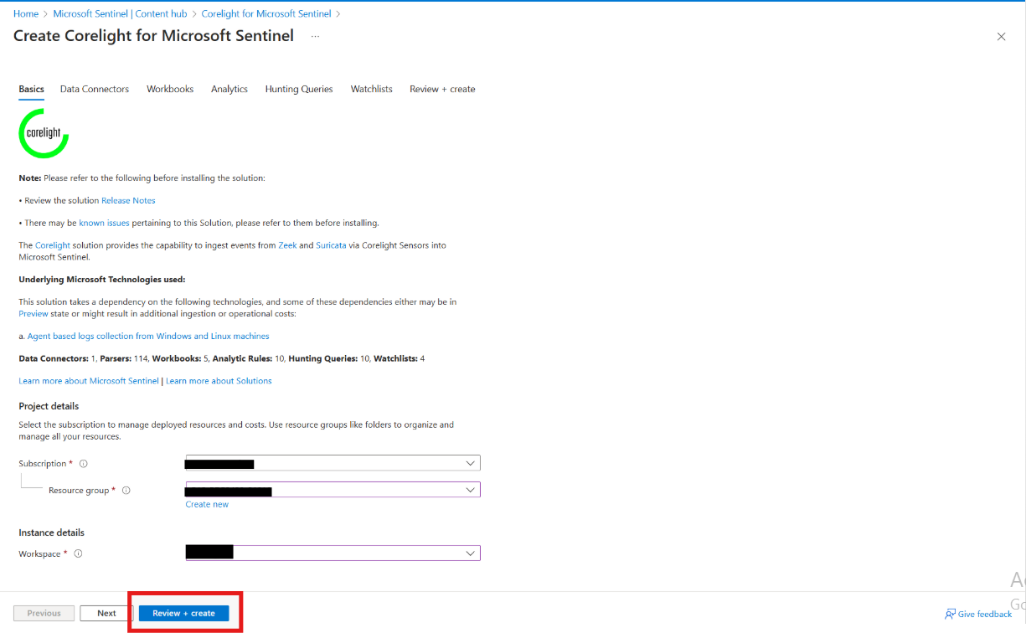

1. Then click on the **Create** button.

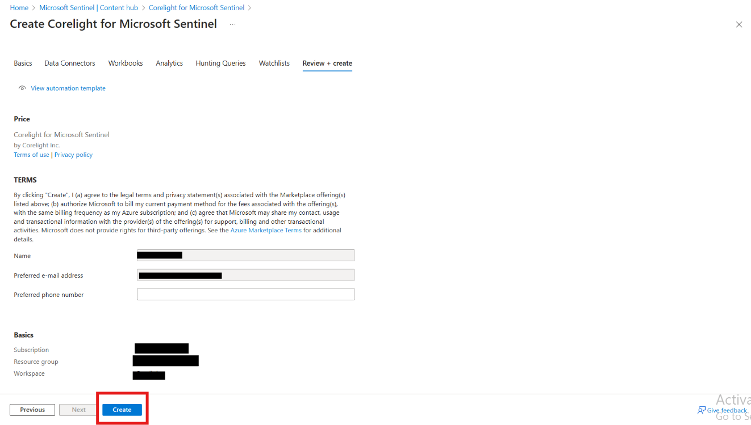

1. It will install the solution into the Microsoft Sentinel.

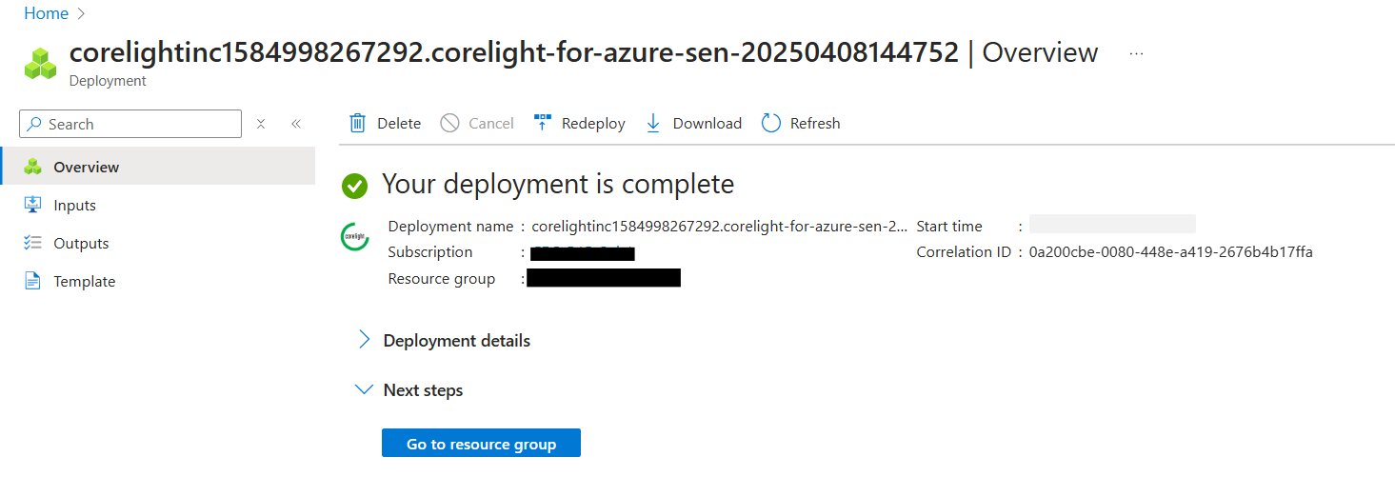

1. Go to Microsoft Sentinel, then go to **Content Hub,** and search for the solution that you have installed and click on **Manage**.

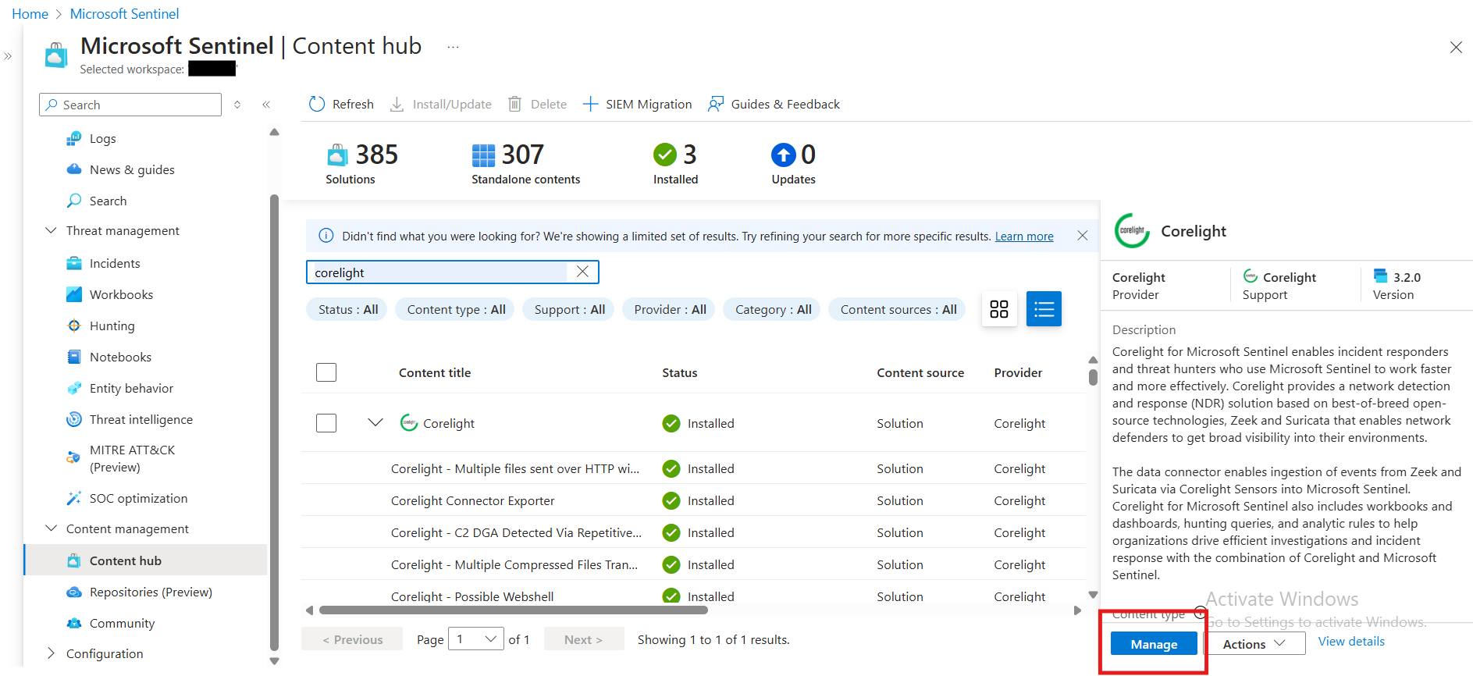

1. After clicking on manage you can see the list of components associated with this integration.

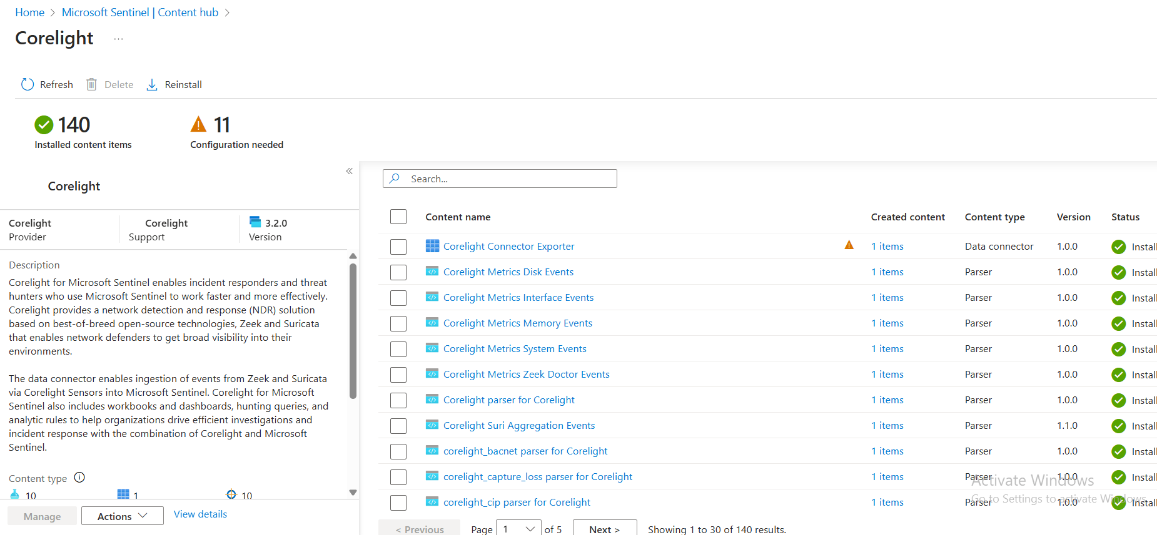

# Steps to Configure the Corelight Workbook (Dashboards)

Workbooks in Microsoft Sentinel provide a flexible canvas for data analysis and the creation of rich visual reports within the Microsoft Azure portal. Corelight Sentinel offers a convenient workbook to analyze various events and logs provided by Corelight

1. There are a total five workbooks provided in Corelight MS Sentinel.
   1. Corelight Workbook
   2. Corelight_Alert_Aggregation
   3. Corelight_Data_Explorer
   4. Corelight_Security_Workflow
   5. Corelight_Sensor_Overview

To instal this workbook, start by navigating to the Microsoft Sentinel homepage:

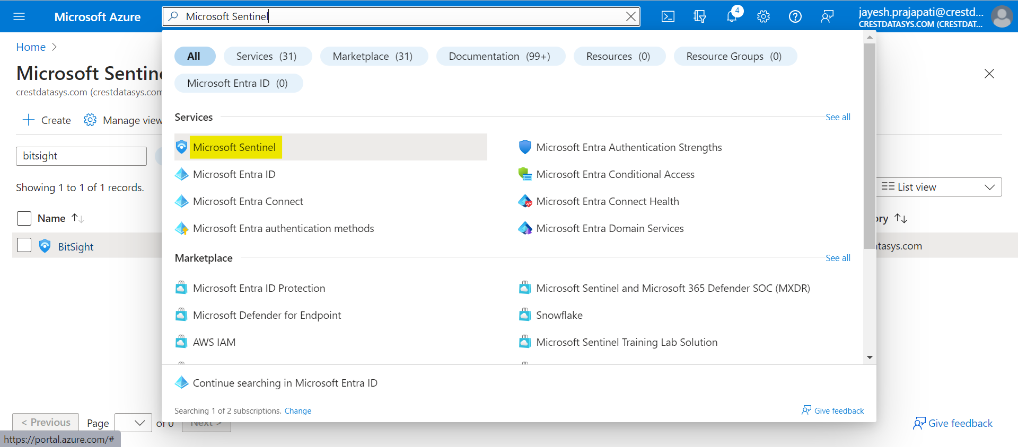

1. Now go to Microsoft Sentinel Workspace in which you have installed the template, go to Workbooks, search for the Corelight, click on installed workbook and Click on **save**.  
   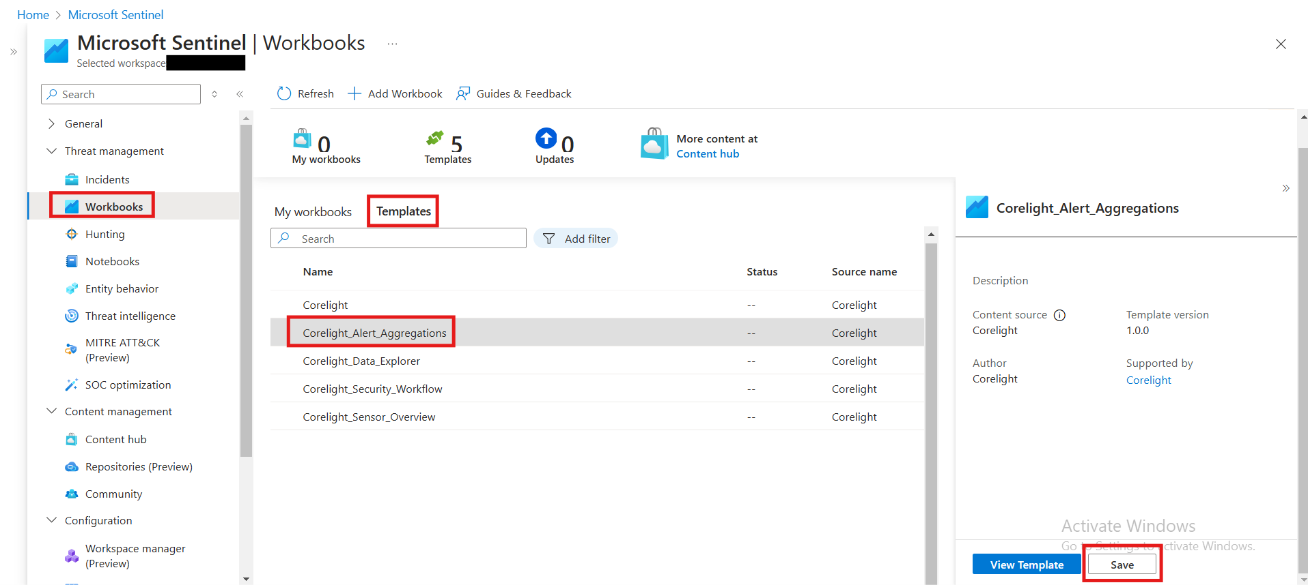
2. Select the location of your Microsoft Sentinel Workspace and click on **Yes**.  
   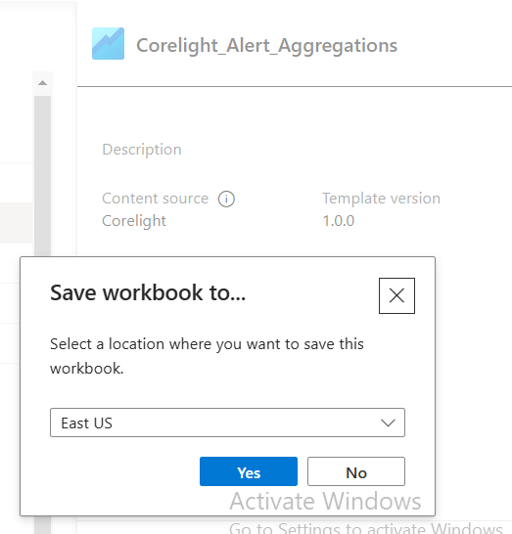

1. After successful completion, you will be able to see the “View saved workbook” button to see the configured workbook.  
   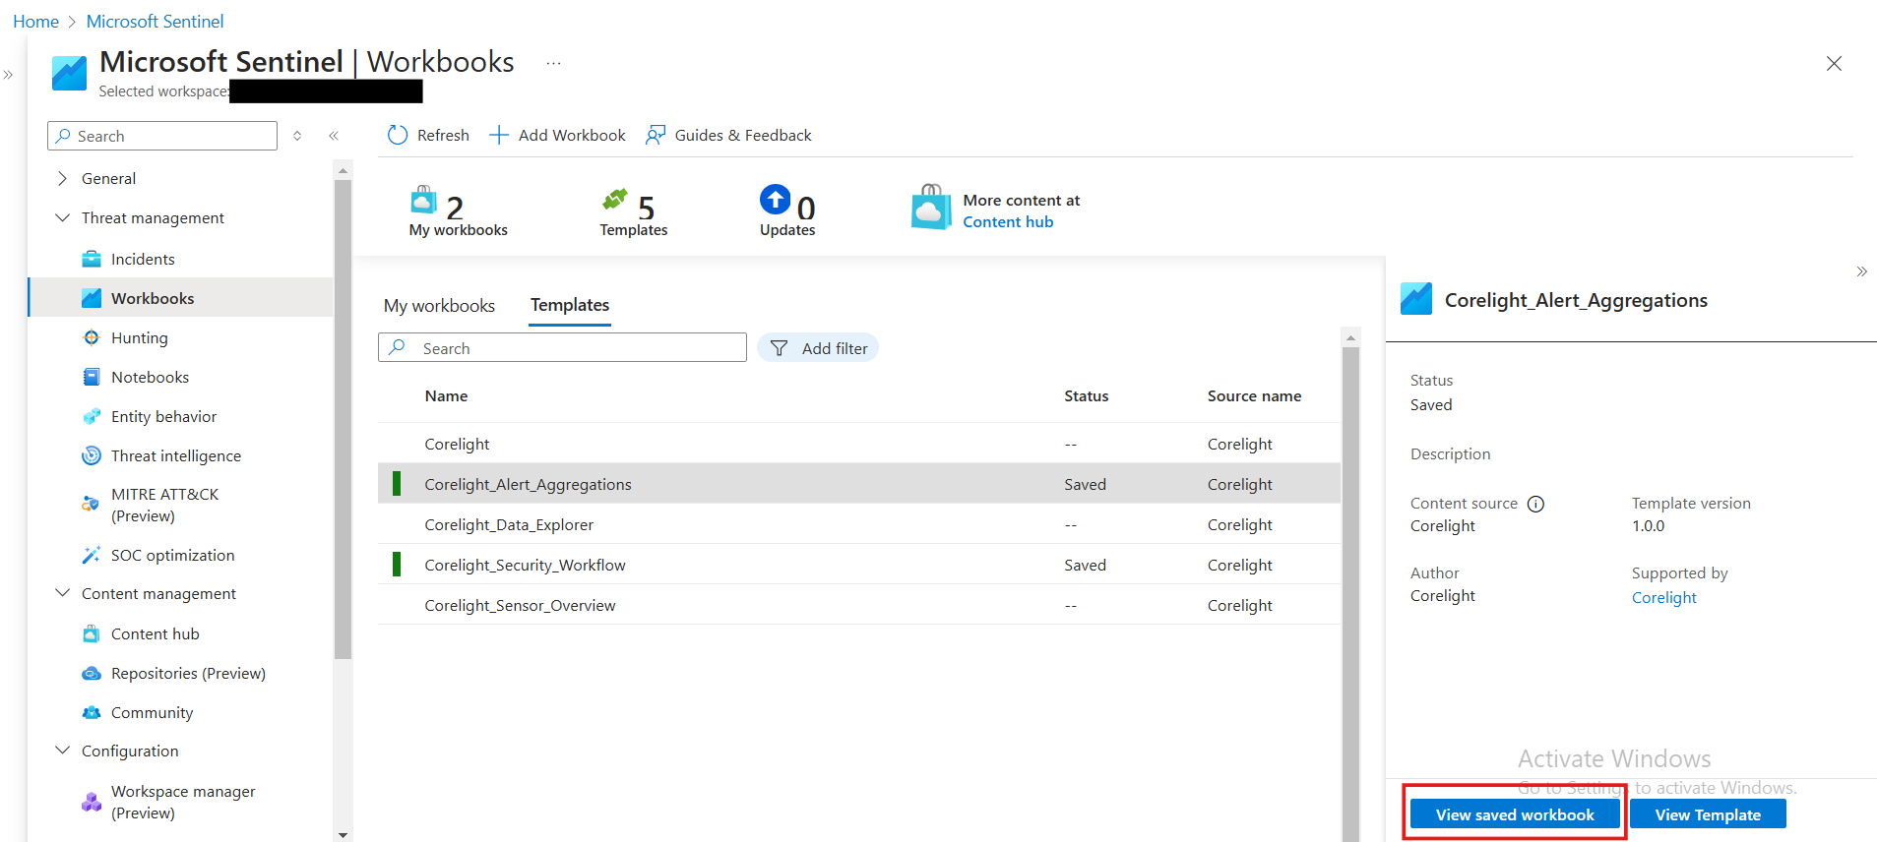

# Steps to Install the Corelight Parser

The **workbook** uses a parser based on a Kusto Function to normalize fields. For Corelight, it’s required to have all the parsers available. Without a parser, the workbook won’t be able to access the ingested data.

1. Once you install the Corelight solution, all the parsers are automatically installed to their correct location, so there is no need to install them separately.  
   Note: Marked one parser - corelight_conn for the reference

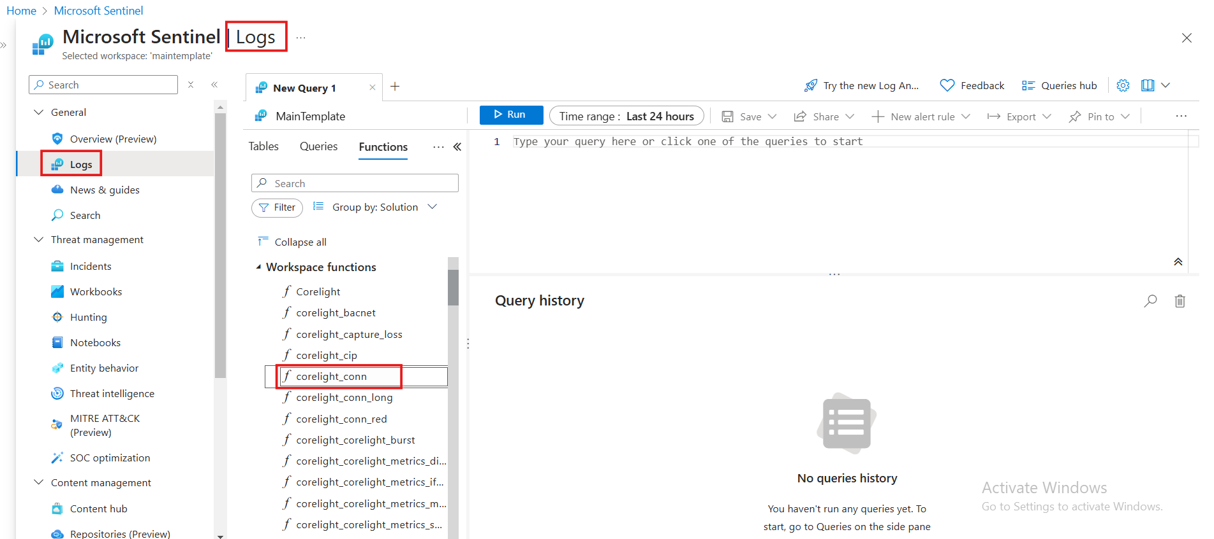

# 

# Steps to update Watchlist

* The Watchlist in Microsoft Sentinel is used to efficiently manage and correlate data from external sources like Corelight, which provides high-fidelity network telemetry and security analytics.
* To efficiently analyze and correlate network telemetry from Corelight within Microsoft Sentinel, you can import structured CSV data into a watchlist. A watchlist enables you to store and reference external data sources.
* Once you install the Corelight solution, the temporary watchlists are automatically installed to their correct location, so there is only need to update csv files.
* Follow the mentioned steps:
  + This workbook requires you to import two CSV files into specific Watchlists:
    - CorelightAggregationsEnrichment1.csv -> CorelightAggregationsEnrichment1 Watchlist
    - CorelightAggregationsEnrichment2.csv -> CorelightAggregationsEnrichment2 Watchlist

1. Navigate to the Microsoft Sentinel

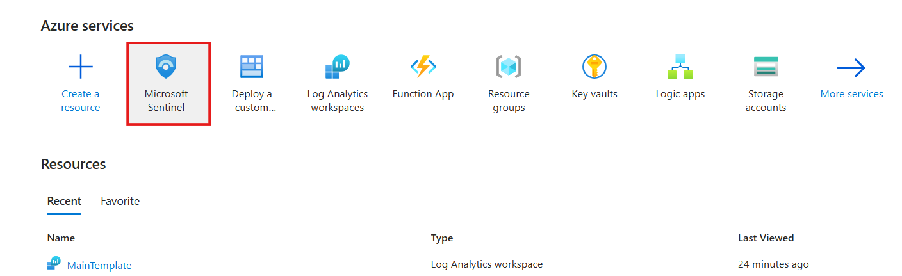

1. Search your workspace and access the Watchlists section

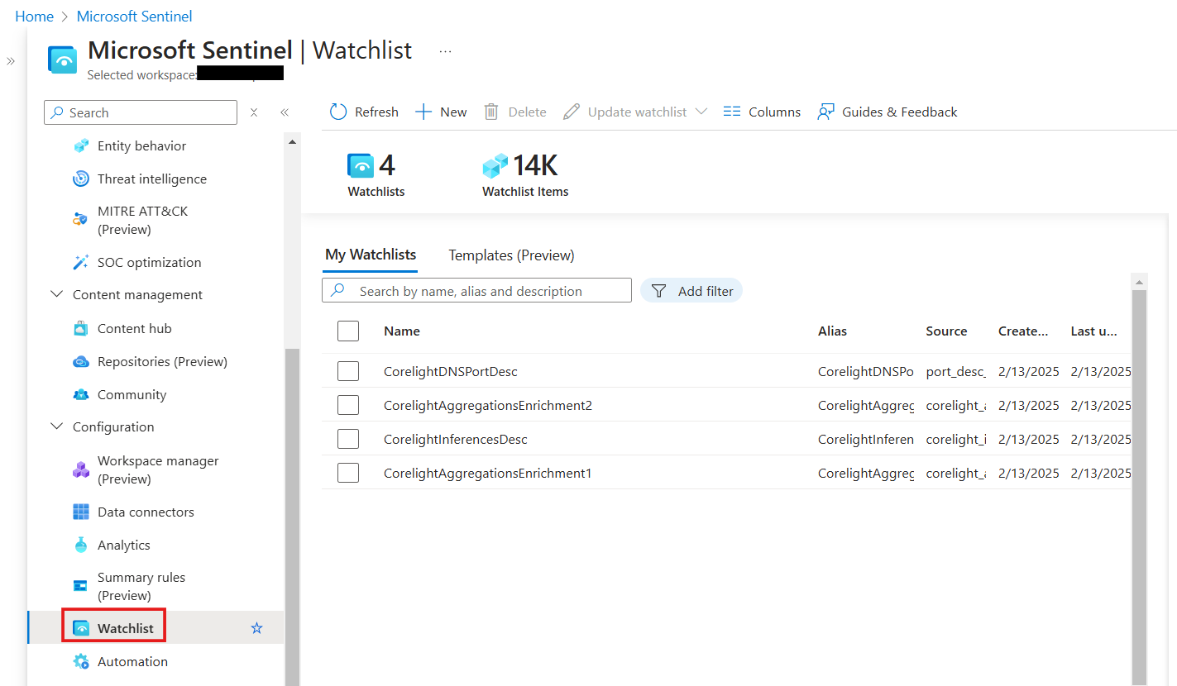

1. Select the appropriate watchlist (**CorelightAggregationsEnrichment1** or **CorelightAggregationsEnrichment2**)

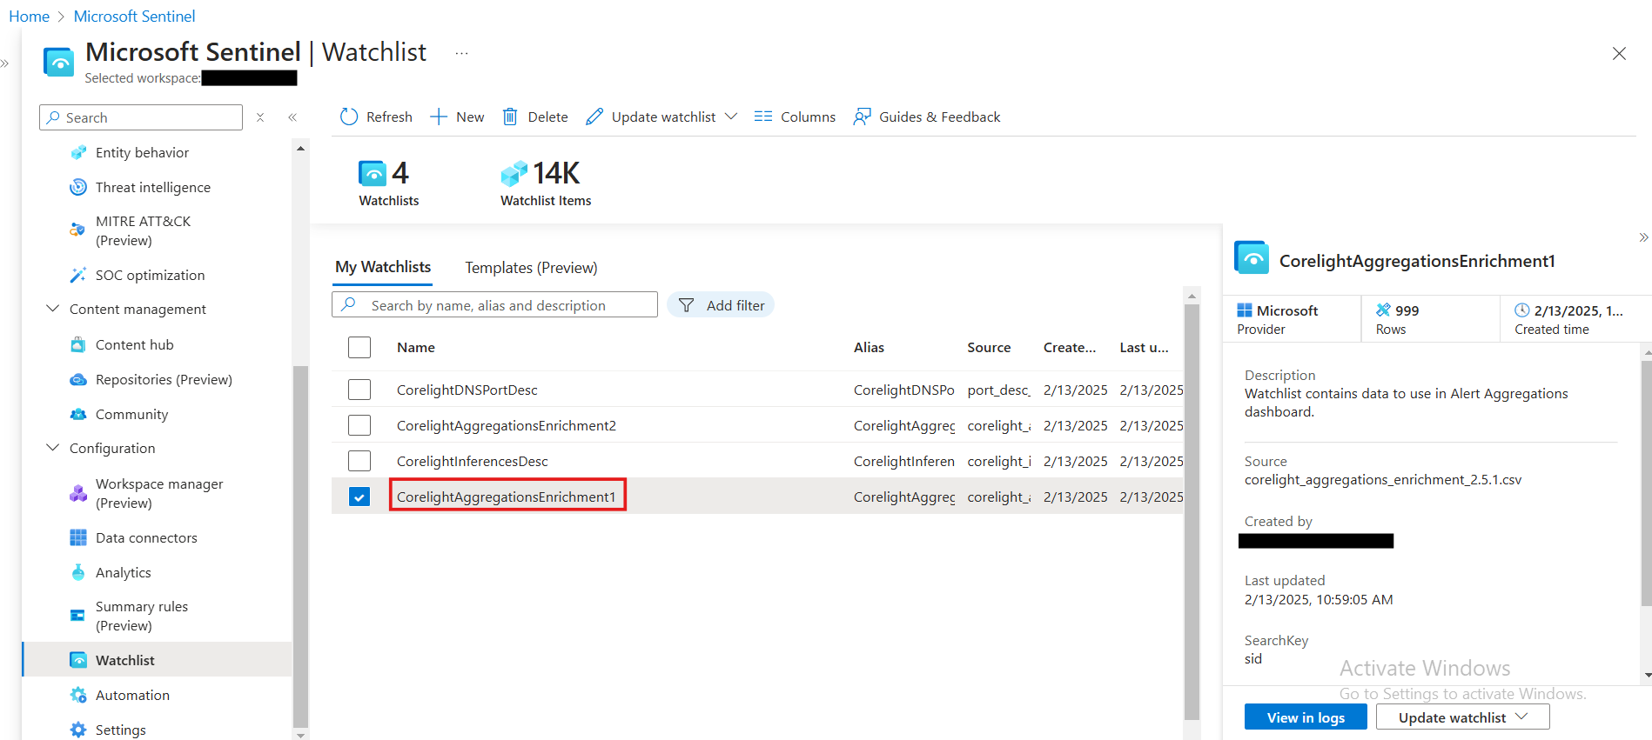

1. Choose **Update watchlis**t -> **Bulk update**

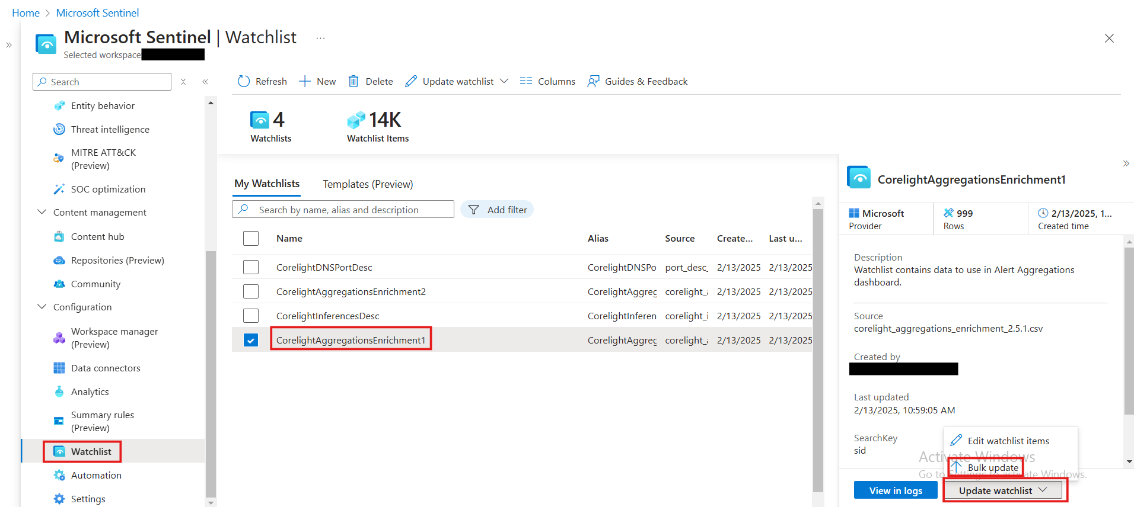

1. Upload the corresponding CSV file

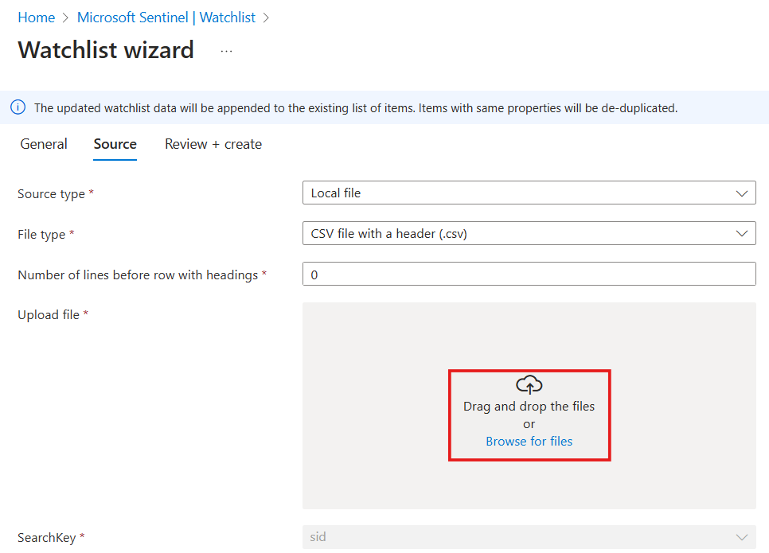

1. Proceed through **Next: Review + create**

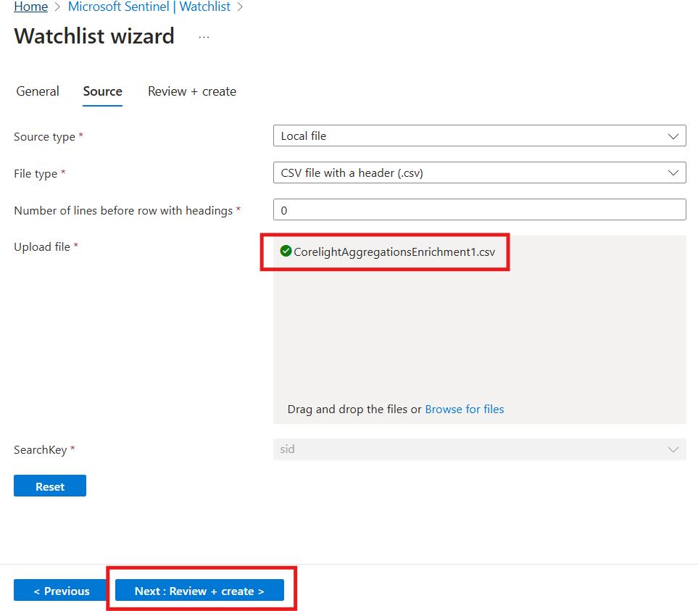

1. Finalize by clicking **Update**

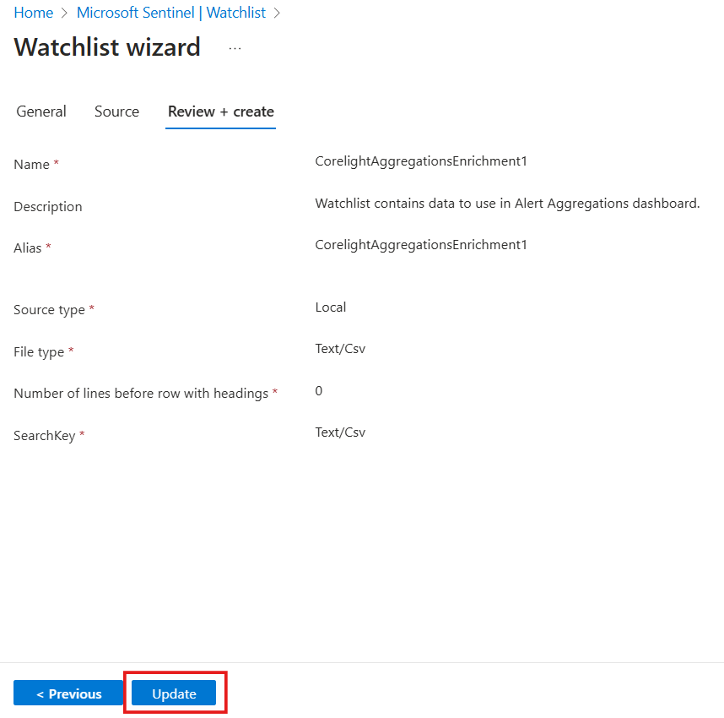

# 

# Limitations

Workbook

| **Visualization/ Parameter** | **Limits** |
| --- | --- |
| Grid | Grids can display 10,000 rows at max. Any further items are ignored, and a warning appears. |
| Charts | Charts are limited to 100 series.  Charts are limited to 10,000 data points. Charts are limited to 50 segments. |
| Maps | Maps are limited to displaying 100 points. Any further items are ignored, and a warning appears. |
| Drop down (Filters) | Drop-down-based parameters are limited to 1,000 items. Any items returned by a query after that are ignored. |
| Drill down | In Time chart, it is feasible but will not get exported time accurately |

Watchlist

* A **maximum of 10,000 records** can be stored per watchlist.
* The **file size limit** for a CSV upload is **3.8 MB**.